Field firmware update instructions for Model 621 wavelength meter

1. Unzip the upgrade files to a directory of your choice.
2. Run the WinPcap_x_x_x.exe program, found in the MityDSPGUI folder and follow the installation wizard’s instructions.
3. Power on your model 621, connect it to the PC with a USB cable, and open the Device Manager (*Start/Settings/ControlPanel/System/Hardware/Device Manager*) and then expand the Com and LPT ports listing to show connected devices. The model 621 will have a description of “SiLabs CP2101…”. Note the assigned com port number.

NOTE: If the instrument is not recognized by the PC, then the appropriate driver will have to be installed by running “BristolVCPInstaller.exe”, found in the VCP_drivers folder.

1. Run the MityDspGUI.exe program.
2. Click on the *Settings* menu and choose *Connection* and input the assigned com port noted in step 3.
3. Set the *Baud Rate* to 921600, and select *Serial*, and then click on “OK”.

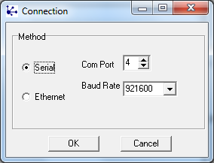

1. Navigate to the model 621 Config screen that contains the command “Reboot”.
2. Select “Reboot now” and press the “Change” button twice.
3. You should see the following MityDspGUI window on your PC with the message “Cannot open port” at the bottom, replaced by “Please start or restart the target…”, immediately replaced by the message “Received configuration from bootloader”, indicating that communication has been established.

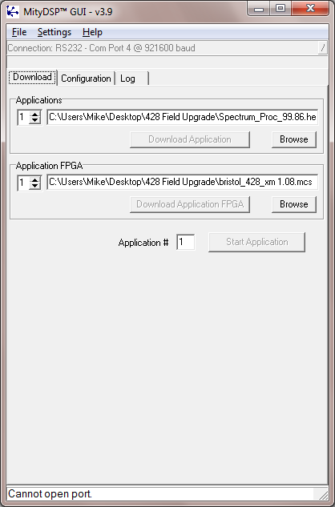

1. Click on the *Browse* button in the Applications box and select the file “<filename>.hex” that is included with the upgrade files.
2. Click on the *Download Application* button and wait until the message at the bottom of the window reads “Successfully downloaded operational code”.
3. Click on the *Browse* button in the Application FPGA box and select the file “Bristol_721 xxxx.mcs” that is included with the upgrade files.
4. Click on the *Download Application FPGA* button and wait until the message at the bottom of the window reads “Successfully downloaded FPGA code”.
5. Click on the *Start Application* button.
6. The embedded firmware update is now complete.